WESTeRn Nevada Regional Youth Center
Family Handbook

Table of Contents
Welcome 2
Program Overview 3
Vision 3
Program Philosophy 4
Understanding Adolescent Substance Use Disorder 5
Intake Process and First Day Expectations 6
Basic Needs, Clothing, and Personal Items 6
Program Environment and Supervision 7
Treatment Programming and Daily Activities 8
Educational Services 8
Mental Health and Healthcare Services 8
Family Contact and Communication 9
Confidentiality 10
Partnership 10
Support for Families 11
Family Involvement and Engagement 11
Family Session Guidelines and Expectations 12
Supporting Youth in Recovery 13
Safety, Policies, and Procedures 14
Prison Rape Elimination Act (PREA) 14
Discharge Planning and Continuing Care 15
Contact Information 17
Resources 18


Dear Parents/Caregivers
Welcome to Western Nevada Regional Youth Center (WNRYC). We want to begin by acknowledging the courage it takes to seek support for your child and your family. Choosing treatment is a meaningful step, and we recognize that this moment may come with a mix of hope, concern, uncertainty, and determination. You are not alone in this process, and we are honored to collaborate with you and your child.
Our program is designed to provide a safe, structured, and supportive environment where youth can begin addressing substance use, developing healthy coping skills, and building a foundation for long-term well-being. We approach treatment with compassion, evidence-based treatment practices, and a strong belief in each youth’s capacity for growth and positive change. Just as importantly, we recognize the essential role families play in the recovery process and strive to support parents and caregivers throughout this journey.
Our facility has been serving youth and families since 2000 and is in Silver Springs, Nevada. The State of Nevada Department of Public and Behavioral Health licenses the program which ensures operation and compliance with the highest clinical and facility standards. In addition, the program is overseen by an Operational Technical Committee comprised of County Managers and Juvenile Probation Chiefs from Lyon, Churchill, and Douglas Counties, as well as Carson City, ensuring accountability and collaboration across systems.
We understand that parents often have questions about expectations, progress, confidentiality, and how best to support their child during treatment. Our staff is available to provide guidance, resources, and updates as appropriate, and we encourage open communication within the boundaries of program policies and privacy requirements. This handbook is provided to help parents and caregivers understand what to expect while their child is enrolled in the program. The goal is to promote clarity, transparency, and reassurance as families begin the treatment process, and to ensure parents feel informed and supported throughout their child’s participation in care.
Thank you for placing your trust in our program. We admire your commitment to your child’s health and future and look forward to working together during this important time. If you have questions or concerns at any point, please do not hesitate to reach out to our team.

Program Overview
WNRYC is licensed as a Level 2.1 Intensive Outpatient adolescent substance use treatment program by the State of Nevada Division of Public and Behavioral Health. The program provides structured, clinically based services to both male and female adolescents, twelve through eighteen years of age, who are referred through the juvenile justice system.
Admission requires that youth meet diagnostic criteria for a substance use disorder. Adolescents with co-occurring mental health conditions may be accepted when those conditions do not interfere with their ability to participate in substance use treatment services.
The program fulfills its mission by delivering evidence-based, coordinated substance use and behavioral health treatment while working collaboratively with juvenile courts, youth, and their families. Services are provided within a developmentally informed, person-first framework that emphasizes integrated care, accountability, and family engagement.

Vision
Western Nevada Regional Youth Center ‘s (WNRYC) vision is to support healthier lives for youth and families by promoting recovery and reducing the impact of alcohol and drug abuse.



Program Philosophy
The program is founded on the belief that adolescent substance use disorder is a treatable health condition that requires a compassionate, structured, and developmentally appropriate approach. Treatment is guided by evidence-based practices that recognize the unique physical, emotional, and social needs of adolescents while promoting safety, accountability, and long-term recovery.
We recognize that substance use in adolescence is influenced by multiple factors, including brain development, mental health, family dynamics, peer relationships, trauma, and environmental stressors. As such, treatment addresses the whole person rather than focusing solely on substance use behaviors. Services are individualized to meet each adolescent’s specific strengths, needs, and circumstances.
The program operates within a trauma-informed framework that emphasizes respect, emotional safety, and empowerment. Staff strive to create a therapeutic environment in which adolescents feel supported, understood, and encouraged to develop healthy coping skills, personal responsibility, and resilience. Behavioral expectations are clear, consistent, and designed to support growth and accountability.
Family involvement is considered essential to effective adolescent treatment. Parents and caregivers are viewed as partners in the recovery process and are encouraged to actively participate in treatment planning, family counseling, education, and discharge preparation. The program recognizes the critical role families play in supporting lasting recovery and works collaboratively to strengthen communication, establish healthy boundaries, and promote a stable home environment.
The program is committed to ethical practice, cultural responsiveness, and continuous quality improvement. Services are delivered in accordance with applicable laws, licensing standards, and professional guidelines. Our goal is to support adolescents and their families in achieving sustainable recovery, improved functioning, and positive long-term outcomes.

Understanding Adolescent Substance Use Disorder
Adolescent Substance Use Disorder (SUD) is a complex, treatable health condition that affects a young person’s physical health, emotional well-being, behavior, and development. Addiction is not a result of poor character, lack of discipline, or parenting failure. Rather, it develops through a combination of biological, psychological, social, and environmental factors.
During adolescence, the brain is still developing—particularly the areas responsible for judgment, impulse control, emotional regulation, and decision-making. Substance use during this critical period can interfere with healthy brain development and increase vulnerability to risky behaviors, emotional instability, and long-term substance-related challenges.
In addition, it is important to remember that substance use disorders in adolescents often present differently than in adults. Teens may minimize their use, deny problems, or struggle to recognize the consequences of their behavior. Warning signs can include changes in mood, behavior, academic performance, peer relationships, sleep patterns, or family interactions. Substance use may also occur alongside other concerns such as anxiety, depression, trauma exposure, attention difficulties, or behavioral challenges.
There are adolescents entering treatment who experience co-occurring mental health conditions. Effective treatment addresses substance use and underlying or contributing health care, mental health, and behavioral factors through an integrated and individualized approach. Treatment is designed to support not only abstinence from substances but also emotional growth, coping skill development, improved decision-making, and healthier relationships.
Families often experience confusion, fear, frustration, or guilt when a teen enters treatment. These reactions are common and understandable. It is important for parents and caregivers to know that recovery is a process and that meaningful change takes time. Early intervention and structured treatment significantly improve outcomes for adolescents. This is the reason that family involvement is a critical component of adolescent recovery. Research consistently shows that teens achieve better outcomes when families are informed, engaged, and supported throughout treatment. By gaining a clear understanding of adolescent substance use disorder, families are better equipped to participate in treatment, support recovery, and foster a safe and stable environment for continued growth.

Intake Process and First Day Expectations
The intake process begins with a required family meeting on the first day of admission, which typically lasts approximately three hours. This initial meeting is an important step in establishing a collaborative and supportive foundation for the youth and their family.
During the first-day intake meeting, families will complete and sign all required consent forms and intake documentation. Program staff will provide a comprehensive explanation of the program structure, expectations, policies, and services to ensure both the youth and parents have a clear understanding of how the program operates.
The intake also includes individual and joint interviews with the youth and their parent(s) or guardian(s). These interviews allow staff to gather important information about the youth’s strengths, needs, and goals, as well as family dynamics and concerns. This assessment process helps the program identify how services can best support the youth and work collaboratively with the family to promote positive outcomes.
Families are encouraged to ask questions, share concerns, and actively participate during the intake meeting, as this information is essential in developing an individualized and effective plan of support.
Basic Needs, Clothing, and Personal Items
The program provides for youth’s basic hygiene and clothing needs during their stay. Parents or guardians are required to provide athletic shoes, as appropriate footwear is required for daily activities and recreation.
Parents may, but are not required, to send personal hygiene items of shampoo, conditioner, and face wash. All personal items are subject to program guidelines and approval to ensure safety and consistency within the facility. Additionally, youth are permitted to have five (5) personal photographs of family members or pets only.

Program Environment and Supervision
WNRYC operates within a highly structured and supervised environment designed to promote safety, stability, and accountability. The facility is staffed 24 hours a day by a caring, experienced, and well-trained team.
During daytime hours, a full complement of clinical and support staff is present to provide treatment services, supervision, and support. During evening and overnight hours, at least two staff members are always on duty to ensure continuous supervision, safety, and continuity of care.


Treatment Programming and Daily Activities
While enrolled in the program, youth participate in a range of structured treatment and recreational activities. Treatment services include individual and group programming focused on substance use education, skill development, accountability, and personal growth.
The program operates on a progress-based model rather than a time-based model. Youth advance through the program based on demonstrated engagement, skill acquisition, and behavioral progress. Recreational and pro-social activities are incorporated to support physical health, emotional regulation, positive peer interaction, and the development of healthy daily routines. Daily schedules and service delivery are structured to promote safety, consistency, and therapeutic engagement.
Educational Services
Education remains an important component of each youth’s daily schedule. Youth enrolled in the program attend Eagle Ridge High School, an accredited school serving seventh through twelfth grade students within the Lyon County School District.
Educational services are coordinated in collaboration with the school to support academic continuity and progress during treatment. The program is committed to assessing each student’s individual educational needs and collaborating with educational staff to support individualized education planning and academic success. This coordinated approach helps ensure that youth remain engaged in their education and are supported in achieving their academic goals while addressing treatment needs.
Mental Health and Healthcare Services
Youth have access to mental health and healthcare services designed to support their individual treatment needs. On-site Alcohol and Other Drug (AOD) counselors are licensed or certified professionals who provide substance use assessment, counseling, and ongoing treatment support. In addition, youth have access to licensed mental health therapists, psychiatric services, and medication management as clinically indicated. Care is coordinated to ensure services are appropriate, timely, and responsive to each youth’s unique needs. Treatment planning addresses substance use concerns while also supporting each youth’s overall physical, emotional, and mental well-being.


Family Contact and Communication

Family involvement is an essential part of the treatment process. The program is designed to support ongoing, structured communication between youth and their families while maintaining a therapeutic, safe, and confidential environment.
Youth may receive mail and are permitted at least two telephone calls per week with individuals listed on a contact list. The contact list must be preapproved by parents, probation, and the WNRYC treatment team. The contact list will be family members only. Mail should be addressed to the youth and mailed to the facility’s mailing address P.O. Box 330, Silver Springs, NV, 89429. Phone calls are scheduled and supervised in a manner that supports treatment goals and appropriate communication. To protect the confidentiality and privacy of all youth, the program does not accept incoming telephone calls for youth. If the program receives an unsolicited call requesting to speak with or locate a youth, staff are required to respond with: “I cannot confirm or deny that I know that person.” Families will be provided with clear instructions regarding approved methods of contact and the process for reaching the program in the event of an emergency.
Following family counseling sessions, youth may participate in a 30-minute in-person visit with their parent/guardian. These visits are intended to reinforce therapeutic progress, strengthen family relationships, and support the application of skills.
Home passes may be considered later in the program as a youth demonstrates consistent progress, treatment engagement, and appropriate behavior. Home passes are not guaranteed and are reviewed on an individual basis by the treatment team. Approval is based on clinical recommendations, safety considerations, family readiness, and the youth’s ability to benefit therapeutically from time at home. All home passes must be pre-approved and coordinated through program staff. Families will receive specific instructions regarding pass expectations, supervision requirements, curfews, transportation arrangements, and return procedures prior to any approved home pass.

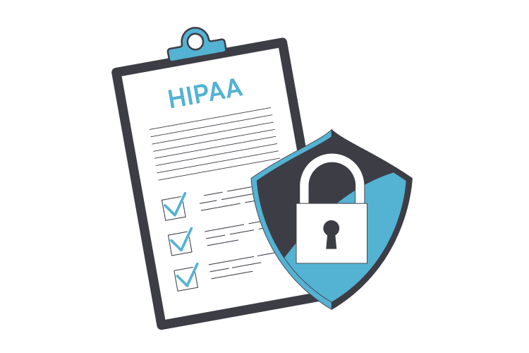
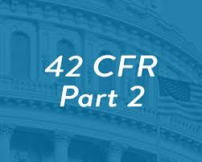
Confidentiality
Communication with parents and legal guardians occurs in accordance with program policies, confidentiality requirements, and applicable state and federal privacy laws. Program staff are available to provide guidance, answer questions, and offer updates as appropriate throughout the course of treatment.
Families are encouraged to ask questions, seek clarification, and contact the treatment team whenever concerns arise. Open and respectful communication between families and staff supports collaboration, understanding, and effective treatment planning.
Communication between families and youth during treatment is structured to support therapeutic goals. Guidelines regarding phone calls, visitation, written correspondence, and electronic communication are established by the program and provided to families. These guidelines are designed to promote safety, consistency, and therapeutic progress.
In accordance with confidentiality laws and ethical standards, certain information related to an adolescent’s treatment may be protected. Staff will share information with parents and guardians within the limits of written consent and applicable privacy regulations. This approach balances the adolescent’s right to confidentiality with the importance of family involvement in treatment.
Families are encouraged to use approved communication opportunities to offer support, reinforce treatment goals, and maintain healthy boundaries. Adhering to communication guidelines helps create a stable and therapeutic environment that supports the adolescent’s recovery and overall well-being.
Partnership
If questions or concerns arise at any time, parents and caregivers are encouraged to contact program staff. The program values family partnership and looks forward to working collaboratively to support each youth’s treatment and recovery.


Support for Families
Treatment can be a challenging process for both youth and their families. Parents and caregivers are encouraged to approach this experience with patience, consistency, and a commitment to self-care. The program recognizes that recovery affects the entire family system and is committed to supporting not only the youth, but families, throughout this period of growth and change.
Caring for an adolescent in treatment can be emotionally demanding. Parents and caregivers may experience a range of emotions, including stress, grief, fear, frustration, or uncertainty. These reactions are common and understandable. Families are encouraged to acknowledge their own needs and seek appropriate support as part of the recovery process.
The program supports family well-being by encouraging the use of available resources, which may include:
- Parent or caregiver support groups
- Individual or family counseling services
- Community-based education programs and recovery resources
Engaging in support services allows caregivers to strengthen coping skills, reduce stress, and maintain a healthy and stable environment for their child’s recovery. Self-care and ongoing support for families are essential components of long-term success and sustained positive outcomes.
Family Involvement and Engagement
Parents and legal guardians are invited and strongly encouraged to participate in family counseling and family education sessions as part of the treatment process. Family involvement is a critical component of effective adolescent substance use treatment and supports communication, accountability, and long-term recovery.
Family counseling and education sessions are scheduled at a minimum of once every four (4) weeks and may occur more frequently based on family needs, clinical recommendations, and staff availability. Sessions typically last 30 to 60 minutes. Following each scheduled family session, families are permitted a 30-minute visit with their child.
Participation in these sessions provides families with the opportunity to:
- Engage directly in the treatment process
- Strengthen communication and critical thinking skills
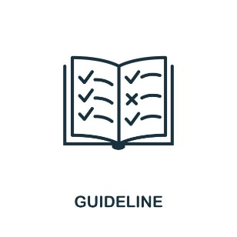
- Receive education related to substance use and recovery
- Support their child’s progress and transition planning

Family Session Guidelines and Expectations
To promote a safe, respectful, and therapeutic environment for all youth, families, and staff, parents and guardians are expected to follow the guidelines outlined below when attending family sessions:
- Arrive on time for all scheduled appointments. If you are ill or unable to attend, please reschedule by calling 775-577-4200 ext. 13 as soon as possible.
- Alcohol and drugs, including tobacco and vape products, are strictly prohibited on WNRYC premises. Visitors must not be under the influence of drugs or alcohol upon arrival.
- Children are not permitted to attend family sessions and must not be left unattended in vehicles.
- Family pets are not allowed on the WNRYC premises and should not be left unattended in vehicles.
- Wear sensible and conservative clothes. Clothing must be appropriate for a treatment setting and may not include bare midriffs, low-cut or see-through garments, or items displaying slogans or logos that promote violence, substance use, gang activity, criminal behavior, or discrimination. Shirts and shoes are always required.
- WNRYC follows a “nothing in, nothing out” policy. All personal belongings must be left in your vehicle, except for identification and car keys.
- For your safety and the safety of others, all visitors are required to always follow staff instructions.
Failure to adhere to these guidelines may result in modification, rescheduling, or cancellation of the visit or session.


Supporting Youth in Recovery
Recovery is a process that involves growth, learning, and ongoing support. Adolescents in treatment are developing new skills, coping strategies, and patterns of behavior while addressing substance use and related challenges. Families play a critical role in supporting this process both during treatment and as youth prepare for continued recovery.
Parents and caregivers are encouraged to support recovery by reinforcing program expectations, maintaining consistent structure, and modeling healthy behaviors. Providing encouragement while holding youth accountable helps promote responsibility, confidence, and progress. Recovery is most effective when support is balanced with clear and appropriate boundaries.
It is important for families to understand that progress may not be linear. Adolescents may experience setbacks or periods of resistance as they adjust to treatment expectations and lifestyle changes. These challenges are addressed clinically and should be viewed as opportunities for learning and growth rather than failure. Families are encouraged to remain patient and engaged during these times.
Families can support their youth’s recovery by:
- Encouraging participation in treatment and educational activities
- Reinforcing coping skills and strategies learned in treatment.
- Maintaining predictable routines and expectations
- Responding to challenges with consistency, support, and accountability
- Participating in family therapy and aftercare planning
As youth progress through treatment, families are encouraged to prepare for the transition home by participating in discharge planning and continuing care services. Ongoing communication with the treatment team helps ensure that expectations, support, and resources are in place to promote sustained recovery.

By remaining engaged, informed, and supportive, families help create a stable environment that encourages positive decision-making, resilience, and long-term success.
Safety, Policies, and Procedures
The safety and well-being of youth, families, staff, and the community are the program’s highest priorities. To maintain a secure, respectful, and therapeutic environment, the program operates under clearly defined policies and procedures that guide daily operations, treatment services, and family participation.
These policies are designed to promote consistency, accountability, and fairness while supporting effective treatment outcomes. Adherence to program rules and procedures helps ensure that all youth receive care in a structured and predictable setting that supports safety, stability, and recovery.
Parents, caregivers, and youth are expected to review, understand, and comply with all program policies and procedures. Cooperation with these requirements allows staff to provide appropriate supervision, respond effectively to safety concerns, and maintain an environment conducive to treatment and personal growth. Failure to follow established policies may result in corrective action or modification of participation, as outlined by the program.
By working together and respecting program policies, families and staff help create a safe and supportive environment in which youth can focus on treatment, develop healthy skills, and progress toward recovery.


Prison Rape Elimination Act (PREA)
The program is committed to maintaining a safe environment free from sexual abuse, sexual harassment, and retaliation. In compliance with the Prison Rape Elimination Act (PREA), the program maintains a zero-tolerance policy for any form of sexual misconduct involving youth, staff, contractors, volunteers, or visitors.
All allegations of sexual abuse or sexual harassment are taken seriously and are promptly reported, investigated, and addressed in accordance with established procedures and applicable laws. Youth are encouraged to report any concerns immediately, and multiple reporting options are available to ensure safety and accessibility.
Parents and caregivers are encouraged to report any concerns related to youth safety directly to program staff. Retaliation against any individual who reports misconduct or participates in an investigation is prohibited.

Discharge Planning and Continuing Care
Discharge planning is an essential component of treatment and begins early in the recovery process. The purpose of discharge planning is to support a successful transition from structured treatment to continued recovery in the home, school, and community environments. This process is collaborative and involves youth, family, and treatment team.
A central focus of discharge planning is the youth’s ability to apply treatment skills in real-world settings. Youth are supported in developing an individualized, in-depth relapse prevention plan that reflects their specific needs, risks, strengths, and support. This plan is designed to promote accountability, problem-solving, and long-term recovery.
Relapse prevention planning includes education and skill development in the following areas:
- Identifying the circle of control, including recognizing what the youth can and cannot control.
- Practicing right thinking and challenging unhelpful or risky thought patterns
- Recognizing high-risk factors and situations associated with substance use.
- Understanding the impact of seemingly unimportant decisions and how they can contribute to relapse.
- Identifying personal warning signs and early indicators of relapse
- Understanding the substance use cycle, including triggers, thoughts, behaviors, and consequences.
- Developing and maintaining healthy leisure activities and structured routines
- Identifying positive support systems, including family, peers, school, and community resources
- Creating safety plans to address high-risk situations, emotional distress, or crisis events
Families play a critical role in supporting discharge and continued care. Parents and caregivers are encouraged to participate in discharge planning meetings, review relapse prevention plans, and support the consistent use of learned skills at home. Maintaining structure, communication, and accountability helps reinforce treatment gains.
As part of continued care support, the program offers bi-monthly continued care meetings for youth following discharge. These meetings provide an opportunity to reinforce treatment skills, review relapse prevention strategies, address challenges, and maintain connection with supportive resources. Participation in continued care meetings is strongly encouraged as an added layer of accountability and support during the transition period.
Continued care recommendations may also include outpatient counseling, substance use treatment services, family therapy, educational support, medical services, psychiatric services, and community-based recovery resources. Following discharge recommendations and maintaining engagement in support services significantly improves long-term recovery outcomes.
Sustained recovery requires ongoing effort, consistent skill use, and supportive relationships. By remaining engaged in continued care services and applying treatment tools in daily life, youth and families are better equipped to support lasting recovery and positive growth.

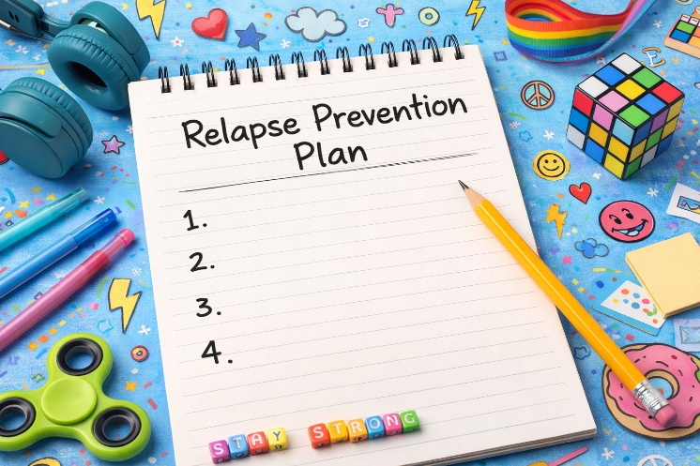

Contact Information
Becky Messick, Director
CADC 0397, CS 00542-S
P.O. Box 330
Silver Springs, NV, 89429
775-577-4200 ext. 33
beckym@wnryc.org

Tyler Creel, Youth Advisor Supervisor/PREA Coordinator
P.O. Box 330
Silver Springs, NV, 89429
775-577-4200 ext. 31
tylerc@wnryc.org

Gwendolyn Moresi, Office Manager
P.O. Box 330
Silver Springs, NV, 89429
775-577-4200 ext. 10
officemanager@wnryc.org

Kevin Quint, Alcohol and Drug Counselor Supervisor
LADC 143
P.O. Box 330
Silver Springs, NV, 89429
775-577-4200 ext. 27
kevinq@wnryc.org

Rachel Trujillo, Alcohol and Drug Counselor II
LADC 07912
P.O. Box 330
Silver Springs, NV, 89429
775-577-4200 ext. 18
rachelt@wnryc.org

Lindsay Welty, Alcohol and Drug Counselor I
CADC-I 07543
P.O. Box 330
Silver Springs, NV, 89429
775-577-4200 ext. 28
lindsayw@wnryc.org

Resources

Nevada Online Resources for Families Supporting Youth in Early Recovery

State and Community Behavioral Health Support
- Nevada Division of Public and Behavioral Health (DPBH) – State agency overseeing behavioral health services, treatment programs, and licensed providers in Nevada. https://dpbh.nv.gov
- BehavioralHealthNV.org – Searchable database of certified behavioral health providers in Nevada, including substance use disorder and co-occurring treatment services. https://behavioralhealthnv.org
- Nevada 211 – Addiction Services & Support – Listings of outpatient treatment, residential programs, recovery housing, prevention efforts, and SAPTA community services. https://www.nevada211.org

Statewide Recovery Support
- Foundation for Recovery – Nevada – Peer support, recovery community centers, sober-social events, and group meetings to strengthen recovery support systems across Nevada. https://forrecovery.org

Crisis Support & Peer Connections
- 988 Suicide & Crisis Lifeline (Nevada) – Call or text 988 for 24/7 crisis support, including emotional distress or urgent mental health needs. https://988lifeline.org
- Crisis Support Services of Nevada (CSSNV) – Northern Nevada crisis intervention via hotline, text, and chat, with de-escalation, safety planning, and support coordination. https://cssnv.org

Family, Peer & Mental Health Resources
- NAMI Western Nevada – Nevada Caring Contacts – Support, education, and peer connection for families affected by mental health and substance use concerns. https://namiwesternnevada.org
- Nevada Behavioral Health Resource Directory (NVBH.org) – Listings of local counseling services, family support groups, and mutual-aid meetings (e.g., Al-Anon, AA). https://nvbh.org/resources

Online Resources for Families Supporting Youth in Early Recovery

National and Family Support Organizations
- SAMHSA (Substance Abuse and Mental Health Services Administration) – Information on treatment, recovery support, and family resources.
https://www.samhsa.gov
- Partnership to End Addiction – Resources for families, guidance on understanding addiction, and recovery support tools.
https://drugfree.org
- National Institute on Drug Abuse (NIDA) – Research-based information on drugs, the brain, and addiction tailored for families and caregivers.
https://nida.nih.gov
- Families Against Narcotics (FAN) – Online support and community for families dealing with substance use disorder. https://www.familiesagainstnarcotics.org
- Al-Anon Family Groups – Support for families and friends affected by someone else’s substance use National Al-Anon https://al-anon.org Nevada Al-Anon https://www.nevadaal-anon.org/

Youth-Focused Recovery & Peer Support
- Recovery.org – Tools to find treatment and information on substance use and recovery pathways. https://www.recovery.org
- Teen Mental Health (TeenMentalHealth.org) – Resources on coping skills, mental health education, and early warnings. https://teenmentalhealth.org

Education & Skill Building
- The National Child Traumatic Stress Network (NCTSN) – Resources for understanding trauma and supporting resilience. https://www.nctsn.org
- CDC Youth Risk Behaviors & Prevention – Information on risk behaviors, prevention science, and adolescent health. https://www.cdc.gov/healthyyouth

Relapse Prevention & Recovery Tools
- SMART Recovery Family & Friends – Tools and support for families of individuals in recovery based on evidence-informed practices.
https://www.smartrecovery.org/family

